# deploying html file from repo to Jenkins slave

- Created 2 slaves
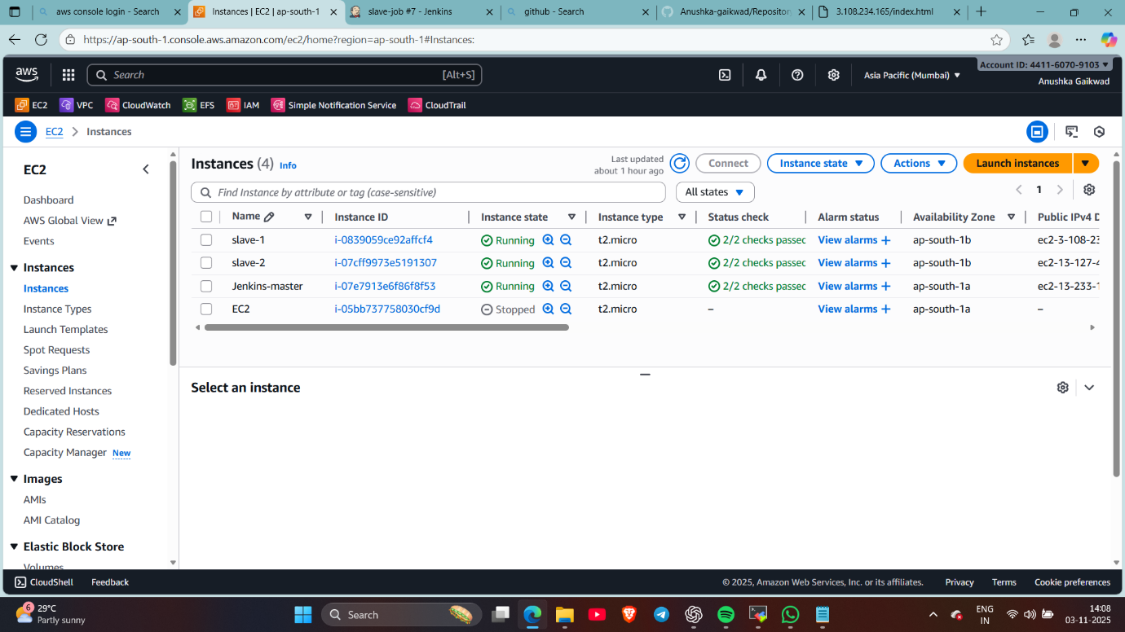
- Install java , created its home /mnt/jenkin-slave and given permission to it on the both the slaves
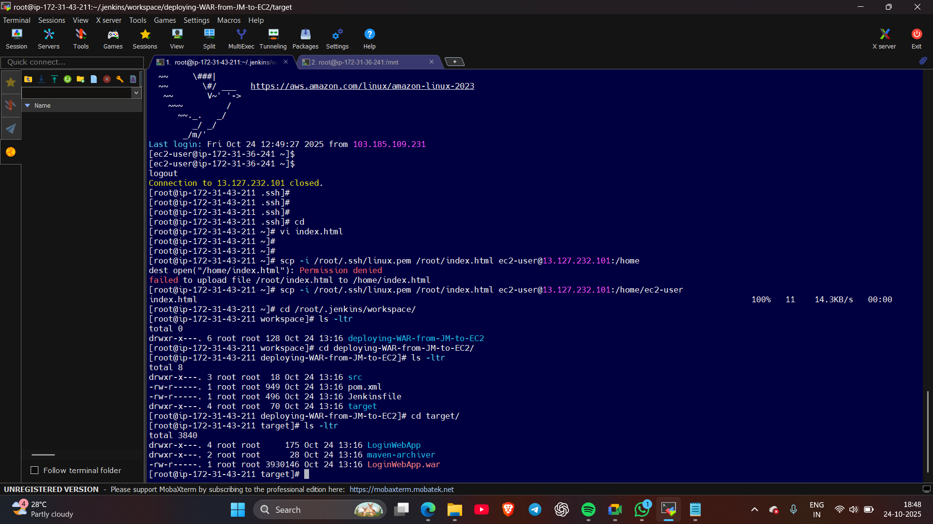
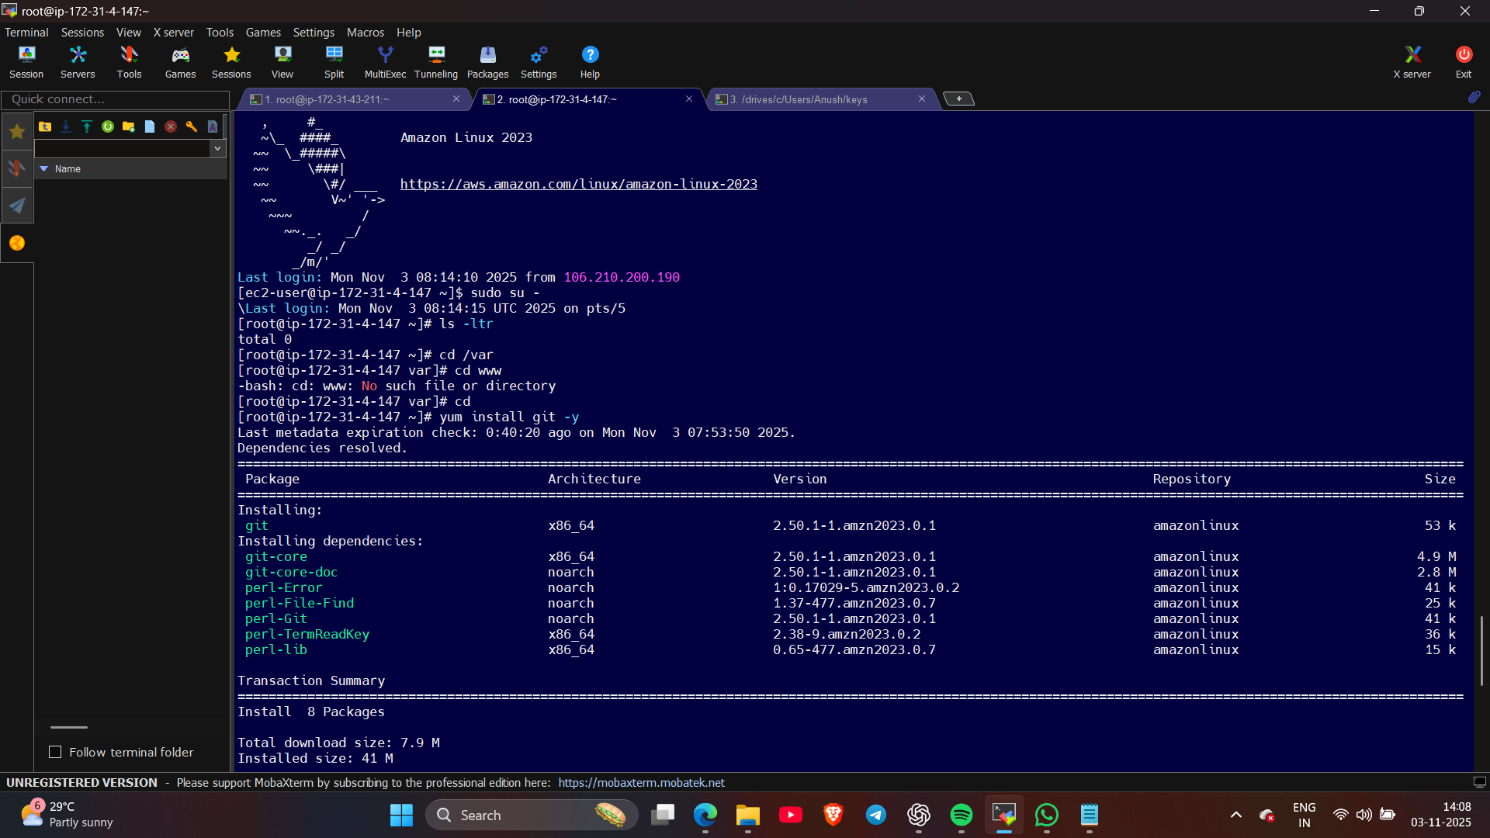
- Done slave configuration of both the slaves/nodes in manage Jenkins
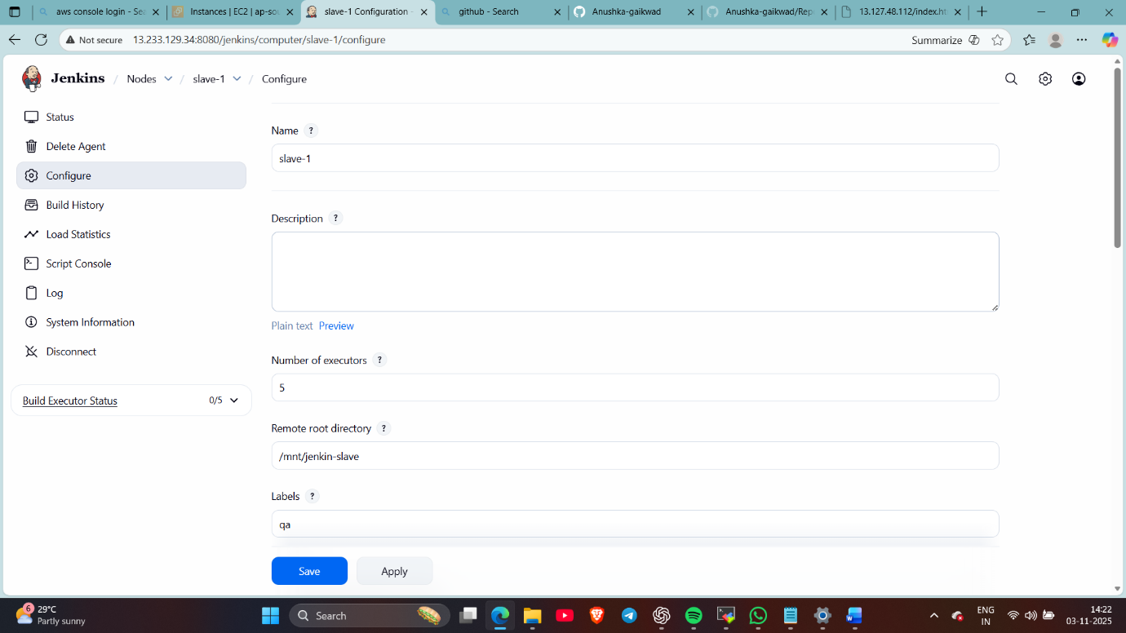
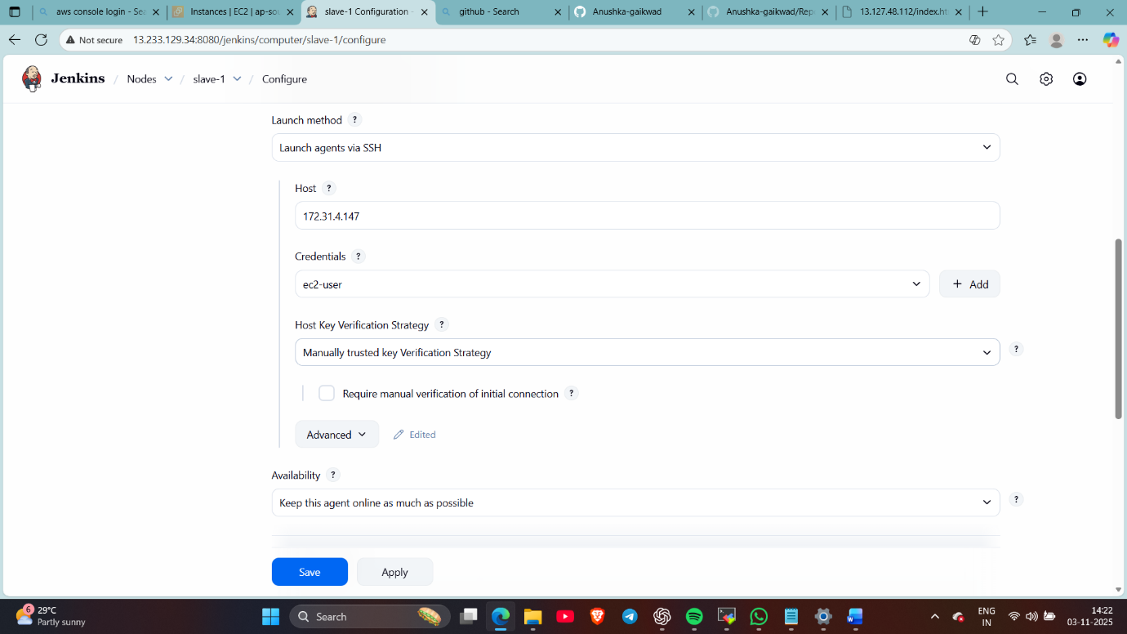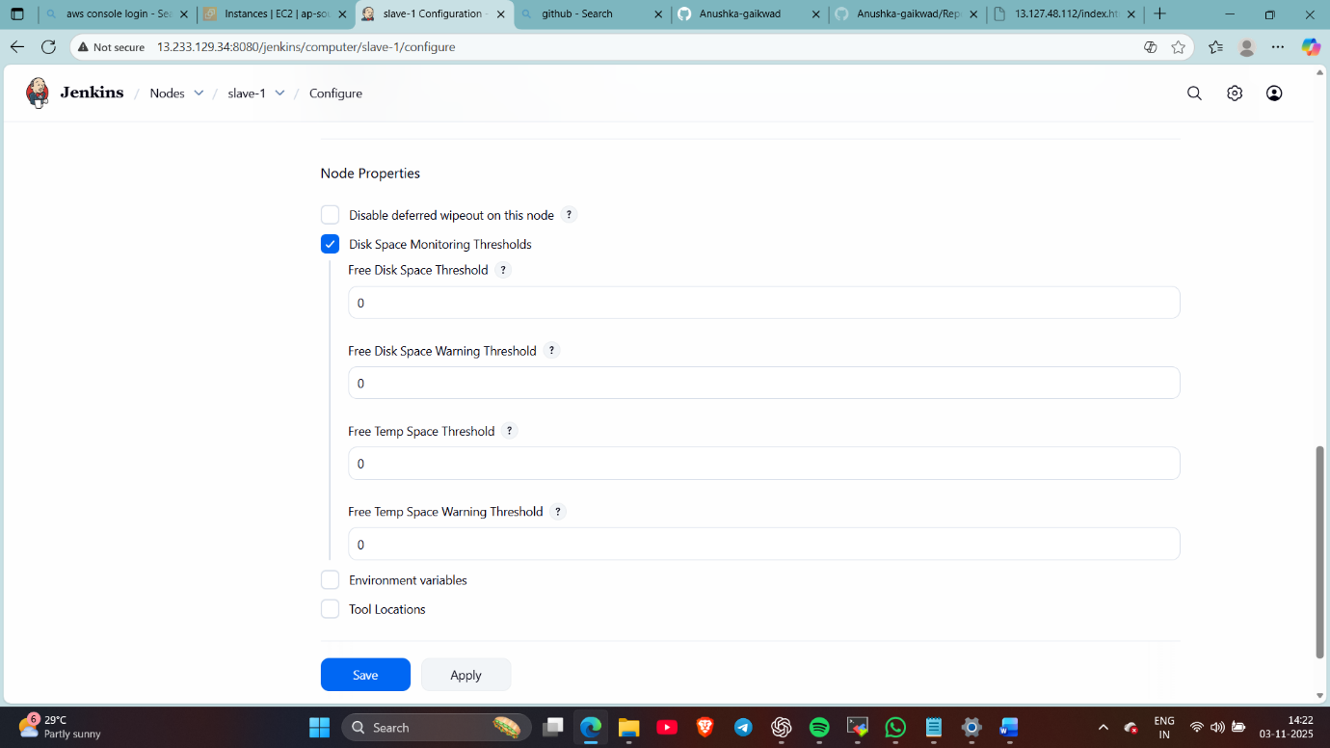
- Create jobs for both the slaves
In slave-1 – put the repo 1 url and mentioned the agent in restrict where this project run and copied index file from repo
Same done in slave-2 only used url of repo 2
(install git at backend of slaves )
(and use sudo in script for slaves)
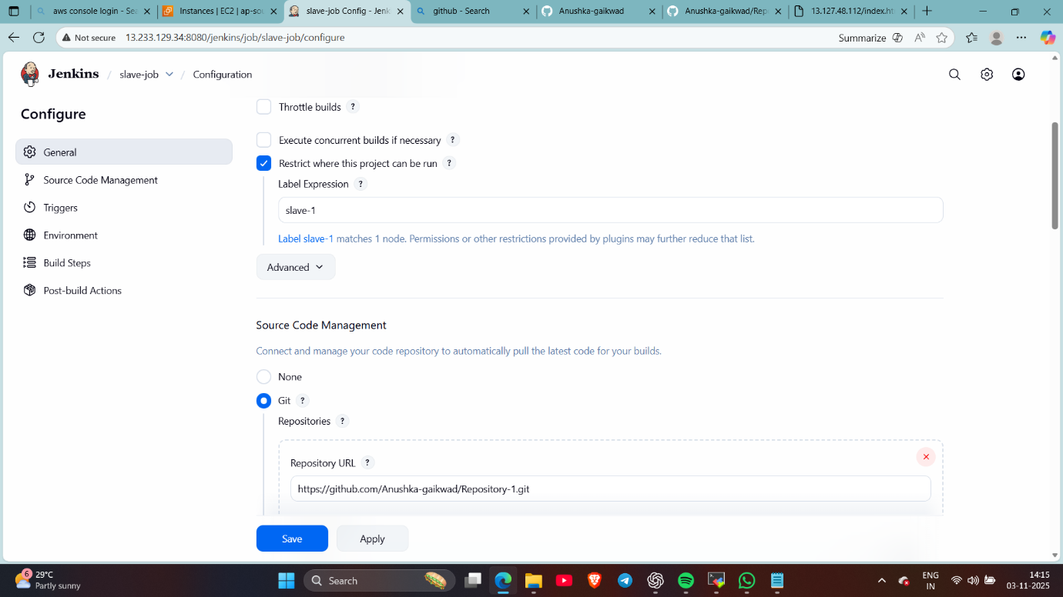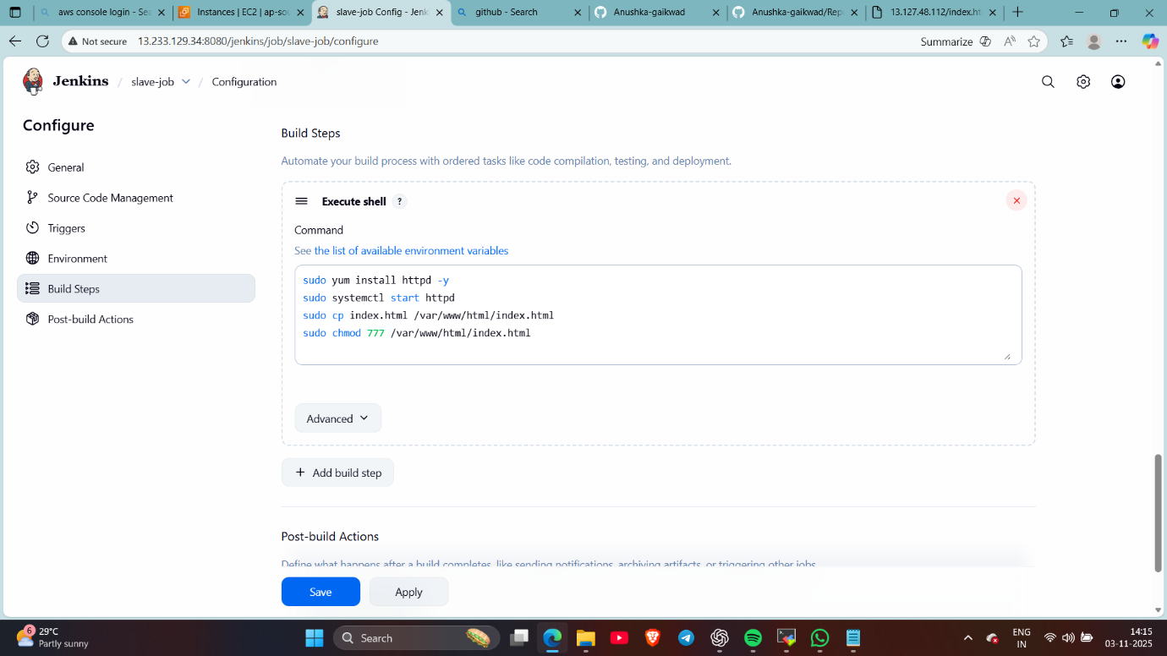
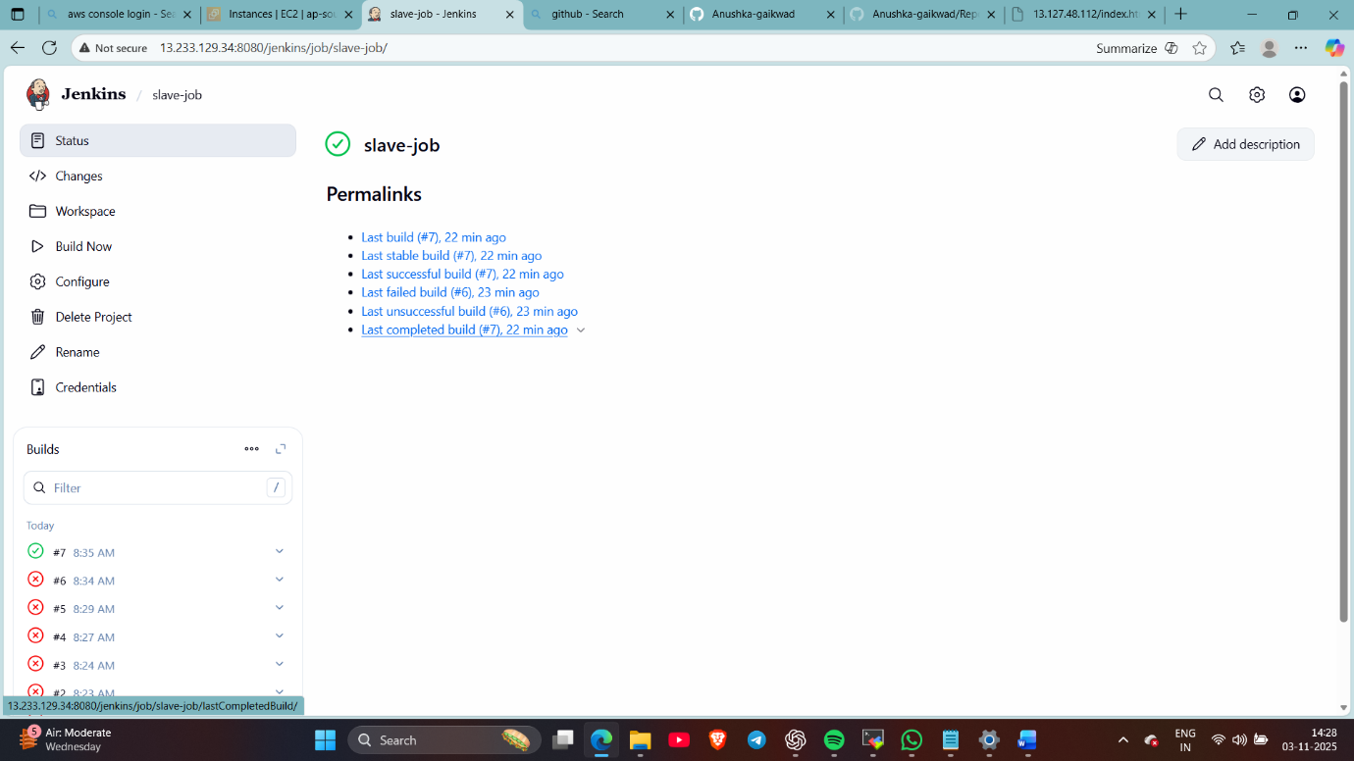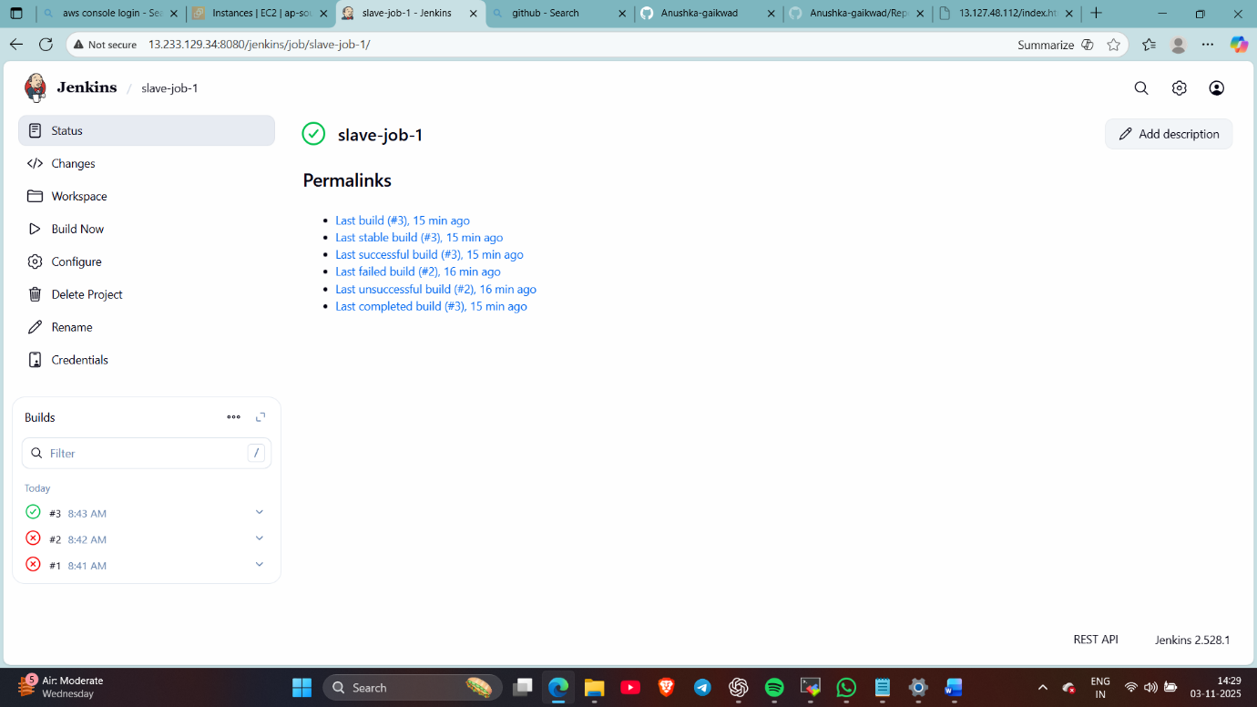
- Now checked whether html files are deployed on httpd


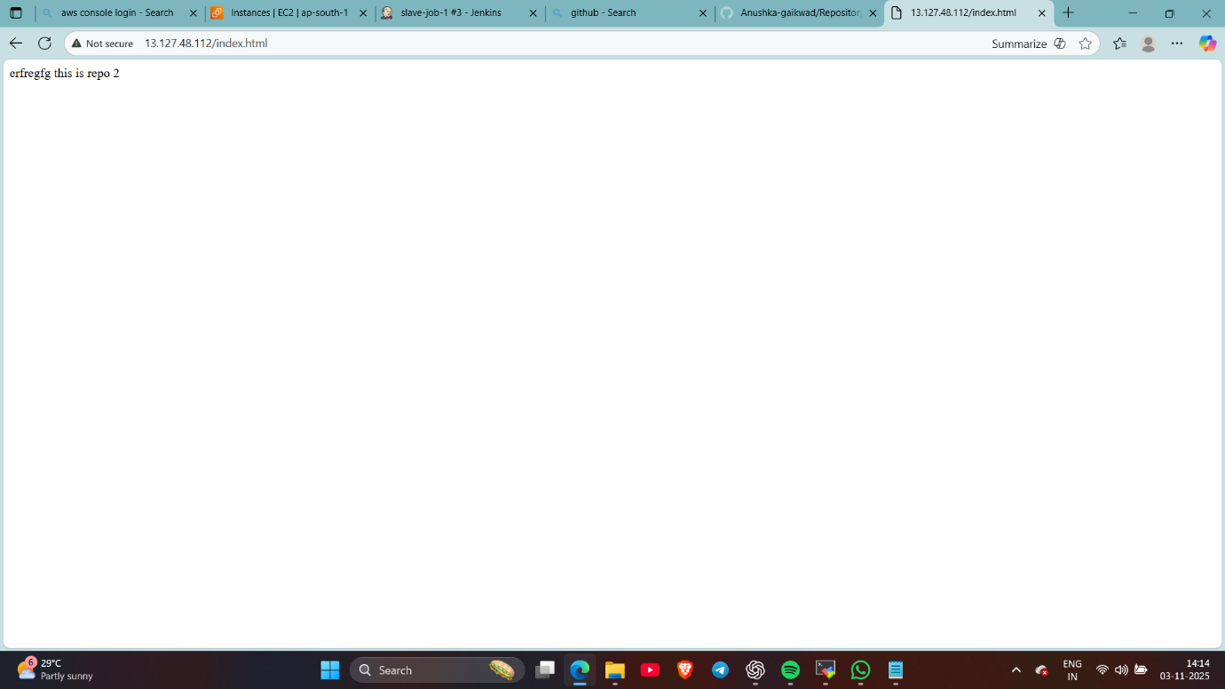
Done..

